Ideation Phase

Brainstorm & Idea Prioritization

Date | 5 April 2026
Team ID | SWTID-2026-5153
Project Name | Automating employee data
Maximum Marks | 4 Marks

Brainstorm & Idea Prioritization:
Brainstorming involves generating ideas to automate employee data processes, such as onboarding automation, centralized databases, and system integration. These ideas are then grouped into categories like HR processes, on boarding, and data integration. Next, the ideas are prioritized based on their importance and feasibility, considering factors like impact, cost, and ease of implementation. Finally, the most effective solutions with high impact and easy implementation are selected for development.
Step-1: Team Gathering, Collaboration and Select the Problem Statement
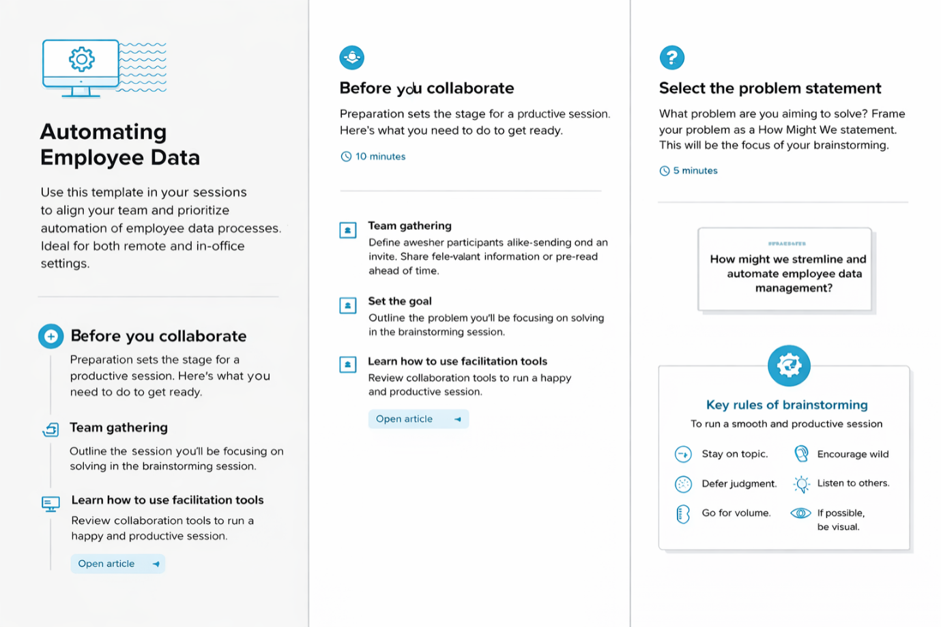

Step-2: Brainstorm, Idea Listing and Grouping
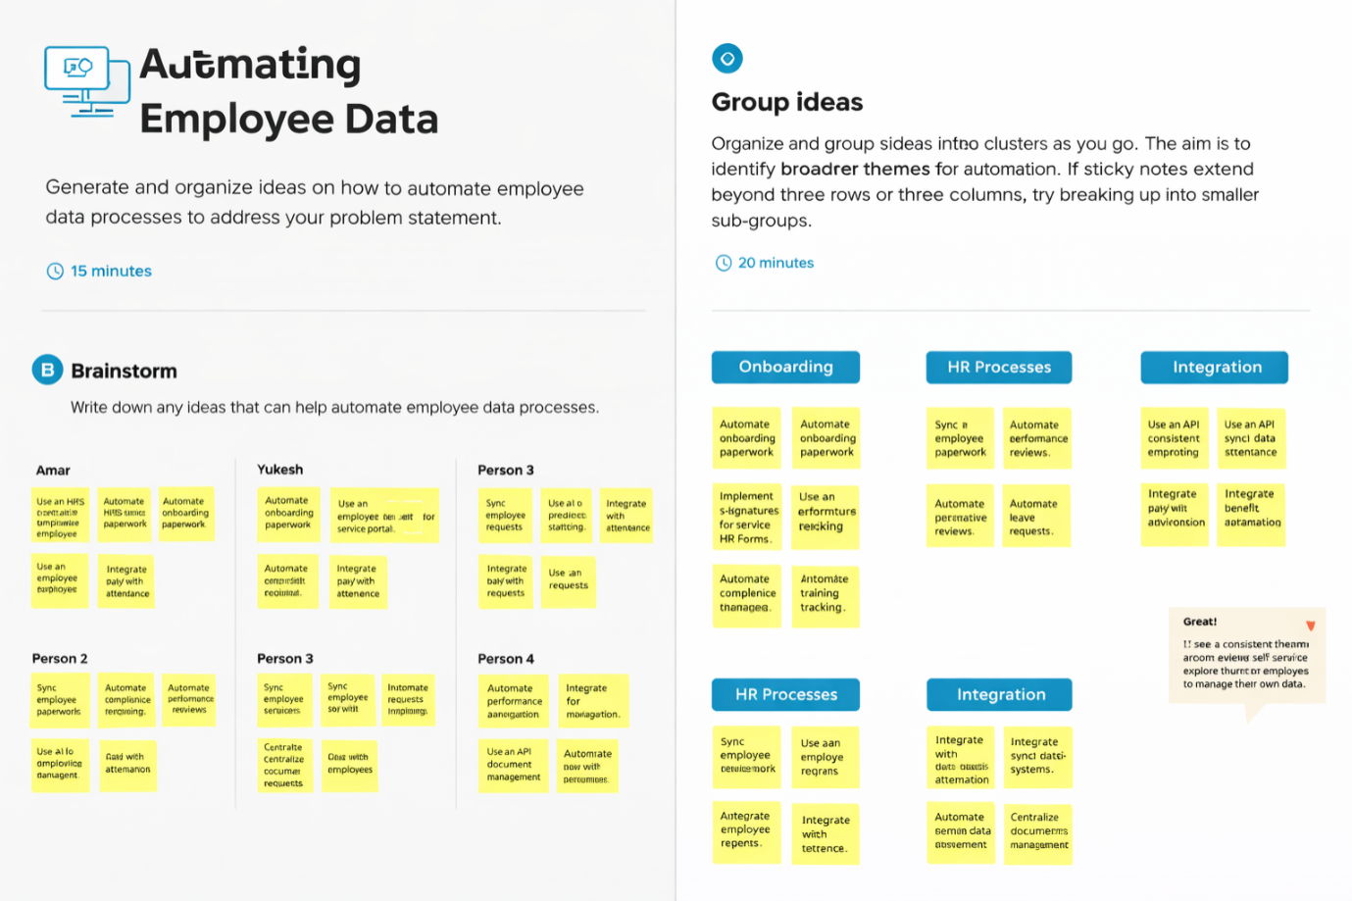

Step-3: Idea Prioritization
